[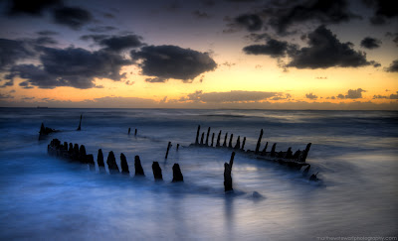](http://3.bp.blogspot.com/-kzPdID-n8RI/Tz3V6H4_fhI/AAAAAAAAAv4/WincEKybLEI/s1600/dawn.jpg)

I’ve taken all the beating and t’was the final blow, would it be all right if I felt a little low? All my miseries are about to be laid to rest, and I know that tomorrow, you won’t be here to test. I’ve managed the ordeal, and you’ve delivered your sermon too, eventually, I’ll rise above and join the worthy few, so let me hold this fleeting moment in my palms, and bid goodbye to past with open arms.

*Like setting a bird free?*

Perfection is not in men, but deeds, the little intentions that fill up all needs. For perfect men haven’t existed in spirit and body alike, an Adonis at heart, with a flaw in the spirit slight? What maketh of man, if not his deeds, that only surpass and transcend creed. If I told you the secrets, as I held them dear, would they help me, conquer all fear?

*Like putting faith in faith?*

You’d fail and fall, and I’d be hurt too, but ignited souls, are only, but few. I too would fail, hah! That isn’t something new. Perfection is in character, to persona it is loosely bound, elsewhere it’d be sought, but would never be found.

*It’s within, not without.*

So fall down today, for it shall be the last failing, the seas will drown themselves, tomorrow we set sailing. With tonight’s moon out, let the miserable tides swell, past the night, the sea is ours to dwell.

*A new euphoria fills the morning hereafter, ahoy!!*

***

[](http://3.bp.blogspot.com/-Vz3_MyC4SgI/Tz3WGe1DHjI/AAAAAAAAAwA/f1Hv4mVtOWg/s1600/look_within.jpg)

जीवन भी अजीब है न, हिरन कि भाँती | जीवन भर सार ढूँढ़ते बहार ही घुमते रहते हैं, और तत्व एवं सत्य है कि हमारे अंदर बैठ कर जीवन को महकाता रहता है, कस्तूरी की तरह | त्रिश्नायें क्षणभंगुर हैं, बुलबुले सी, अभी हैं, और अगले ही पल नहीं | परन्तु इन्द्रियों को तो बाह्य ज्ञान ही महसूस होता है, भीतर से तो केवल एहसास की अनुभूति होती है, जो इन्ही इन्द्रियों से व्यक्त होती है | भीतर अरण्य है, पूरी तरह से पत्तों से आच्छादित | एक पगडण्डी है इसमें, जिस पर हम निरंतर चलते हैं, और संकेत ढूँढ़ते हैं, बाहर |

[](http://2.bp.blogspot.com/-KS28XD_1r5g/Tz3WOf-3kGI/AAAAAAAAAwI/S0mR9GET4Kg/s1600/O_by_Brungilda.jpg)